Those Serving Today

In Charge of Services: Brent Fisher | Servers At The Table
Song Leader: Brent Fisher | 1.
Prayer: Joe Stenger | 2.
Lords Table: Scott Baker  Speaker Today: Val Roxby | 3.  4.
Wed. Eve. Announcements: Brent Fisher  Wed. Eve. Song Leader: Brent Fisher |  | Pulpit  1…2...Table..3…4

Usher Foyer_
Don Grear TBD
God's Plan for Salvation  Hear the Gospel  • Romans 10:17  •John 8:32  Believe the Gospel  •Mark 16:16  •Acts 8:37  Repent of Sins  •Acts 2:38  •Acts 17:30-31  Confess Christ  •Matthew 10:32-33  •Romans 10:9-10  Be Baptized – Immersed  •Acts 2:38  •Romans 6:3-5 |  |  |  | Elders  Jeff Allen 740-432-7571  Brent Fisher 740-425-2729  Brad Wilson 740-425-1004  Deacons  Jim Andrews 740-425-3365  Terry McCort 740-425-3130  Andy Sellers 740-213-5987  Minister  Val Roxby 740-310-7664  Mission Fields  Ghana - Ted Wheeler  Ukraine - Jim Orrison  Costa Rica - Phil Grear  Honduras - Dan Doak  Mid-Western Children’s Home  Potter Children’s Home  In Search of the Lord’s Way
REGISTER OF ATTENDANCE AND OFFERINGFERING
Bible Study |  | Morning | Evening |  | Wednesday | Offering  Last Week
31 |  | 40 |  |  | 24 | $1920.00
><>><> Please check the bulletin board for further announcements <><<><

East Main

Church of Christ
 | Sunday – January 3, 2021 | Issue 1
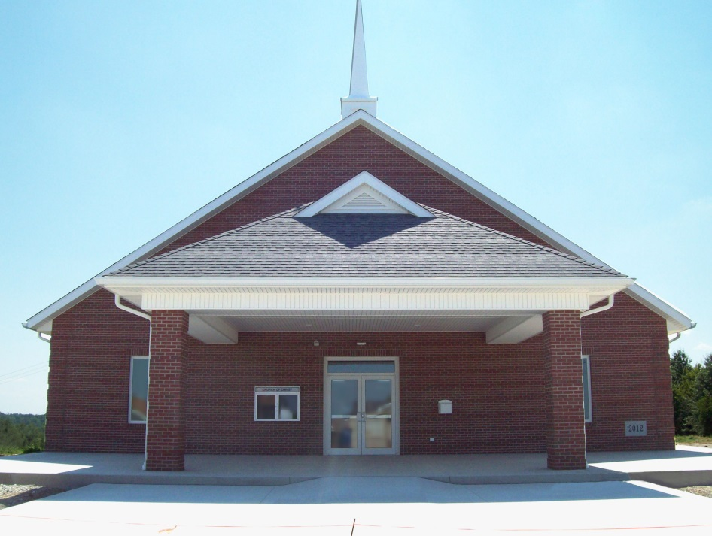
a

329 East South Street • Barnesville, Ohio 43713
Church and Office 740-425-2397
Schedule of Services
Sunday AM Bible Study 9:30
Sunday AM Worship 10:30
Wednesday Bible Study 7:00
Good Morning and Welcome! We are especially glad for our visitors who have chosen to worship with us today. It is our hope that you will feel welcome in our assembly and be uplifted by the service. Please fill out a visitor card and put it in the collection basket.
Our e-mail address: barnesvillecofc@sbcglobal.net
Visit us on the web at: www.eastmaincofc.com
In Search of the Lord’s Way WTRF-TV
Sunday Morning at 7:30 AM
Please turn off cell phones and pagers. Thank You!

EAST MAIN CHURCH OF CHRIST
Sunday – January 3, 2021 Issue 1

SALT AND FIRE

The French anthropologist and folklorist Arnold Van Gennep (1873-1957) coined the name ‘rites of passage’. Passage rites are ceremonial events existing in all societies that mark the movement from one social status to another. Examples would be birth rites, initiation rites, marriage rites and death rites.

Many of these ceremonies are religious. Van Gennep observed three distinct elements in theses customs: (a) separation, (b) transition, and (c) reincorporation. Christian discipleship is a ‘rite of passage’ as defined by Gennep. There is a separation from the old ways of life. Paul admonishes the Corinthians, “be separate, says the Lord, do not touch what is unclean, and I will receive you. I will be a Father to you, and you shall be My sons and daughters, says the Lord Almighty”
(2 Cor.6:17,18).

The transition or passage from one form to another takes place over time. "Beloved now are we children of God; and it has not yet been revealed what we shall be, but we know that when He is revealed, we shall be like Him, for we shall see Him as He is. And everyone who has this hope in Him purifies himself, just as He is pure” (1 John 3:2,3).

The reincorporation takes place at the end when the body is redeemed and the natural becomes the spiritual (Rom.8:23; 1 Cor.15:44).

Jesus said, “everyone shall be salted with fire” (Mark 9:49). The fire will either purify or penalize depending upon the nature of those who pass through it. It will separate those who are acceptable to God from those who are not. Peter asks of us this question, “If the righteous scarcely be saved, where will the ungodly and sinner appear” (1 Peter 4:18)?

“Have salt within you, and have peace with one another”
(Mark 9:50). Val

THOSE IN NEED OF PRAYER
"...by prayer and supplication, ..., let your requests be known to God" Phil 4:6

Frank Brock now at Astoria Place, room 213. It was discovered while at Wheeling Hospital that he has a herniated disc in his back. He will be going through physical therapy while at Astoria Place.

Steve Benson was transferred from Reynolds Memorial to OSU Medical Center for treatment of a severe infection.

Daniel Benson was being treated for Covid-19 at Reynolds Memorial but began having severe respiratory problems and was transferred to Ruby Memorial and is currently there on a ventilator.

NEWS-N-NOTES
"And whatever you do in word or deed, do all in the name of the Lord Jesus..." Col 3:17

In Search of the Lord’s Way has moved to local television station, WTOV-9. It was previously on WTRF-7. You can watch it each Sunday at 8:30 a.m.

Birthdays: Today, Val Roxby; 8th, Andy Sellers.

Happy Birthday to All!!!

